WEEK 3 DAY 2
TASK 2

Identify and Analyze Missing Values
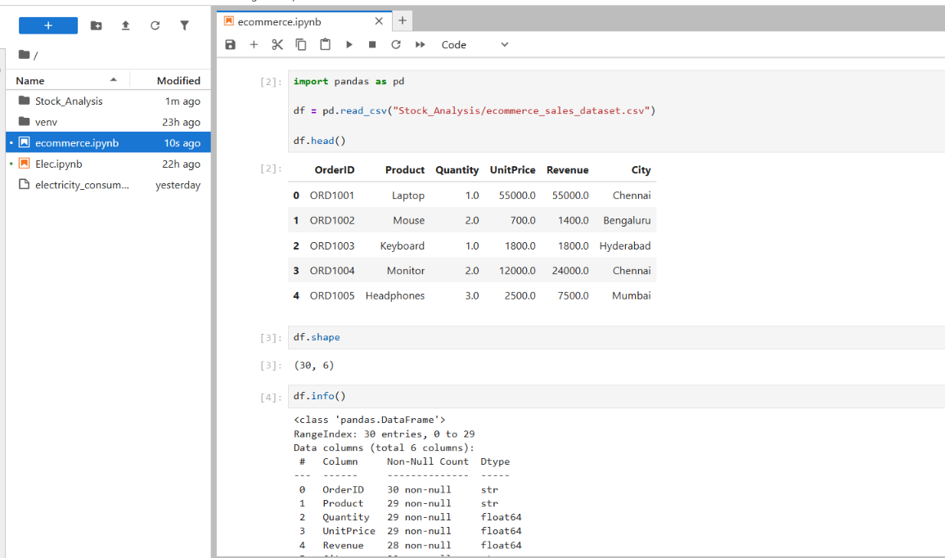
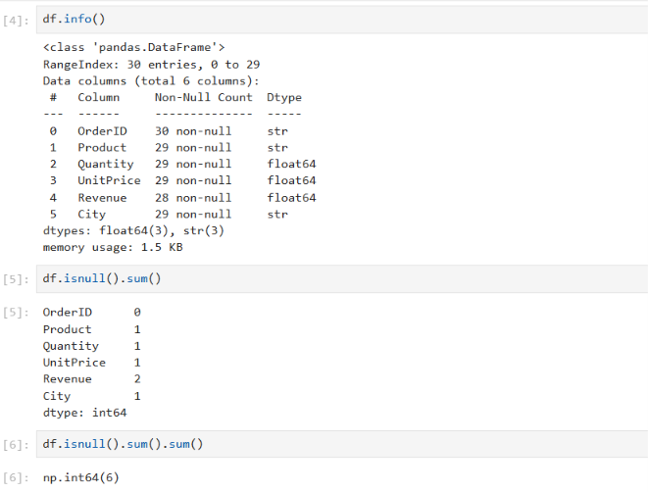
Column | Issue | Suggested handling
Product | Missing product name | Investigate the order record or mark it as unknown if appropriate
Quantity | Missing quantity | Verify the original sales record before filling
UnitPrice | Missing unit price | Verify the product price before filling
Revenue | Missing revenue | Recalculate using Quantity × UnitPrice when both values are valid
City | Missing city | Check the customer or shipping information

Identify Duplicate Orders
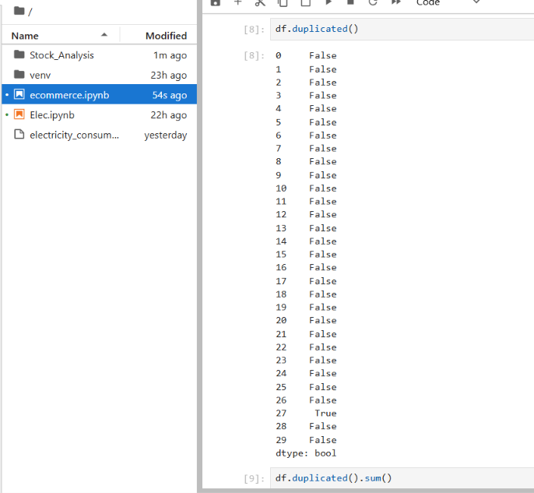

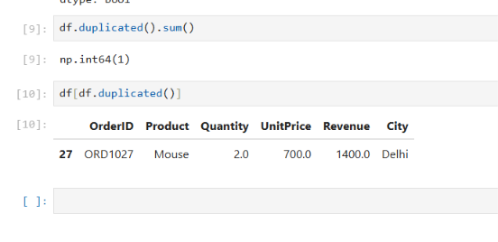

Cause | Reason
Accidental duplicate data entry | The same sales record may have been entered twice.
Data imported multiple times | The same record may have been loaded into the database more than once.
ETL or data pipeline issues | A data processing job may have inserted the same record again after a retry.
Missing duplicate validation | The system may not check whether an identical record already exists.

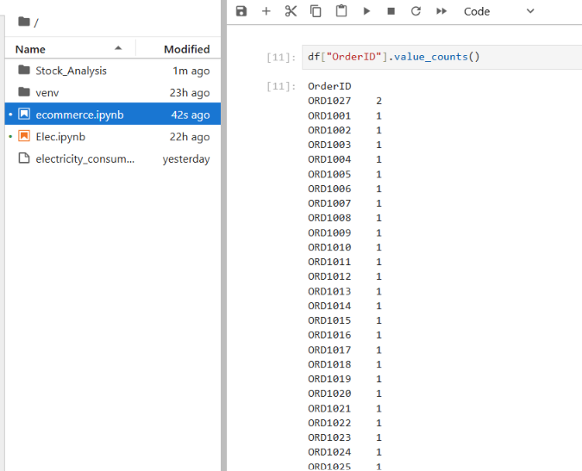

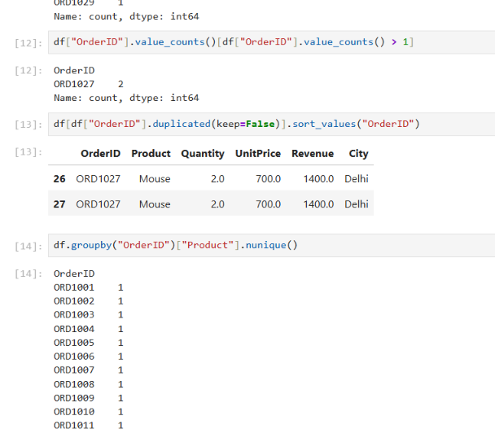

Investigation | Finding | Recommended action
Exact duplicate rows | One deliberately inserted duplicate exists in the practice dataset. | Investigate and remove the duplicate if confirmed to be an unintended record.
Repeated Order IDs | Some order IDs may occur multiple times. | Investigate their associated products and quantities before deciding whether they are duplicates.
Business impact | Duplicate records may inflate revenue and sales counts. | Validate records before calculating business metrics.
Prevention | Duplicate validation may be missing from the data ingestion process. | Introduce appropriate validation and reliable record identification.

Find the Highest-Priced Product
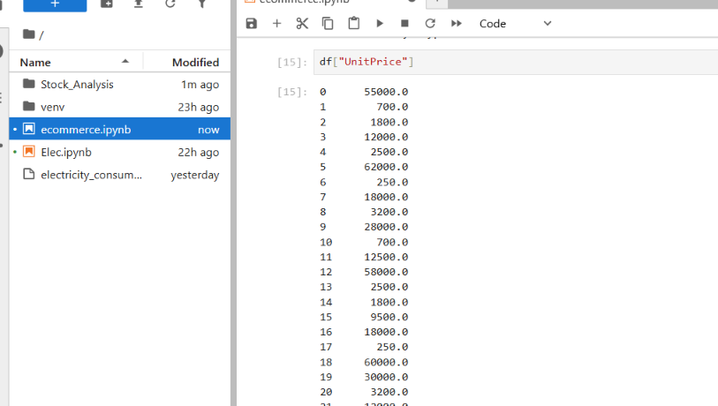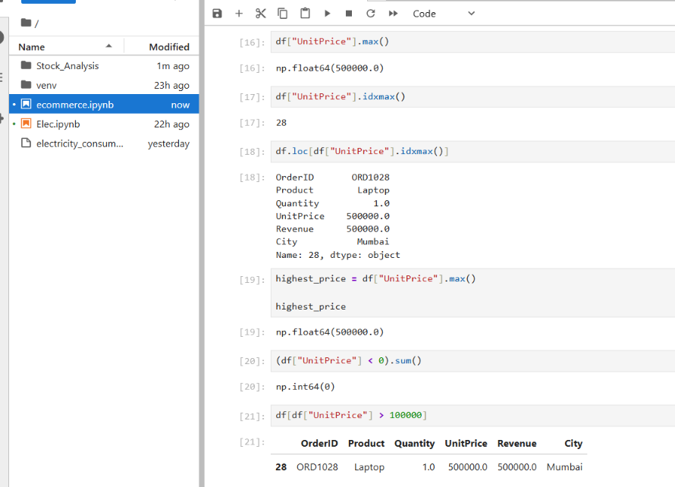

Analysis | Finding
Objective | Identify the product with the highest unit price.
Method | Used max() to find the maximum price and idxmax() to locate its row.
Product details | Retrieved the complete record using .loc[].
Data quality | Checked missing, negative, and unusually high prices.
Recommendation | Investigate extreme prices before deciding whether they are valid or erroneous.

Calculate Total Revenue by City
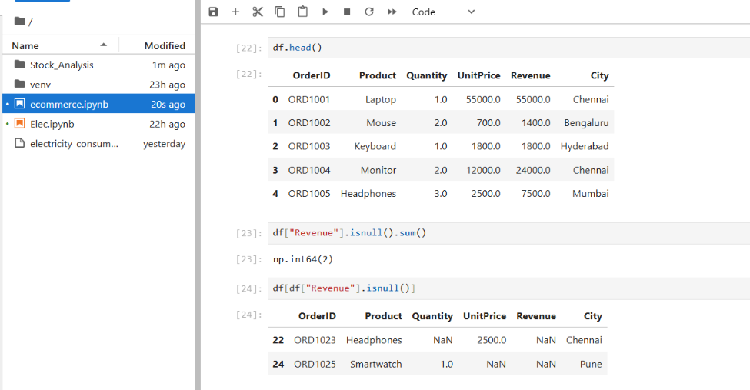

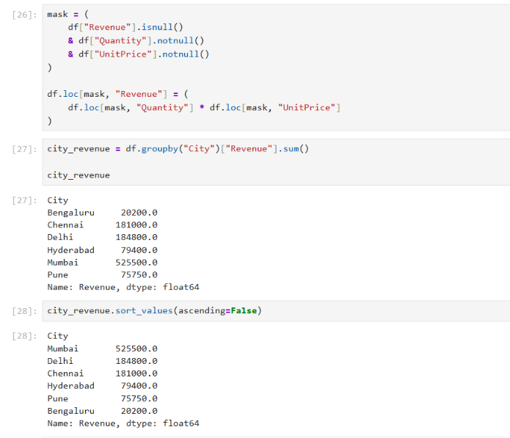
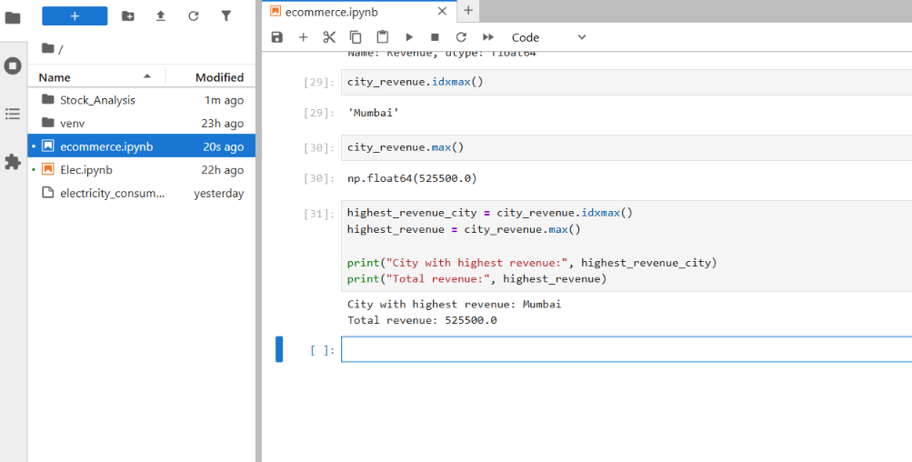

Task | completed | Important Pandas commands
Task 1: Missing Values | Identified missing values and calculated their counts and percentages. | isnull(), sum(), info(), shape
Task 2: Duplicate Orders | Identified exact duplicate rows and investigated repeated order IDs. | duplicated(), value_counts(), groupby(), nunique()
Task 3: Highest-Priced Product | Found the highest unit price and retrieved its complete record. | max(), idxmax(), loc[]
Task 4: Revenue by City | Aggregated revenue by city and identified the highest-revenue city. | groupby(), sum(), sort_values(), idxmax()

